PETG Beannel Testing - Parabolic Lens, Flat lens on top to act as bean container, circular corner reflector

RoastRite Moisture Meter Readings:

* Sweet Maria’s: 9.8%
* Tailored Pulped Natural Brazil: 8.9%
* Comicovel: 7.6%

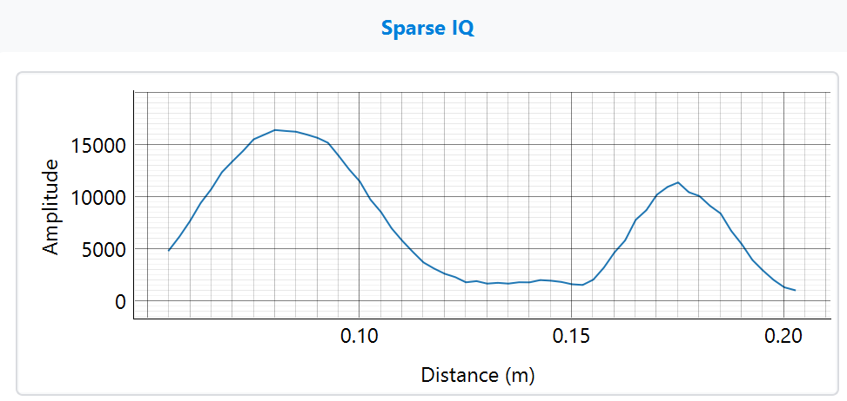Baseline - No beans

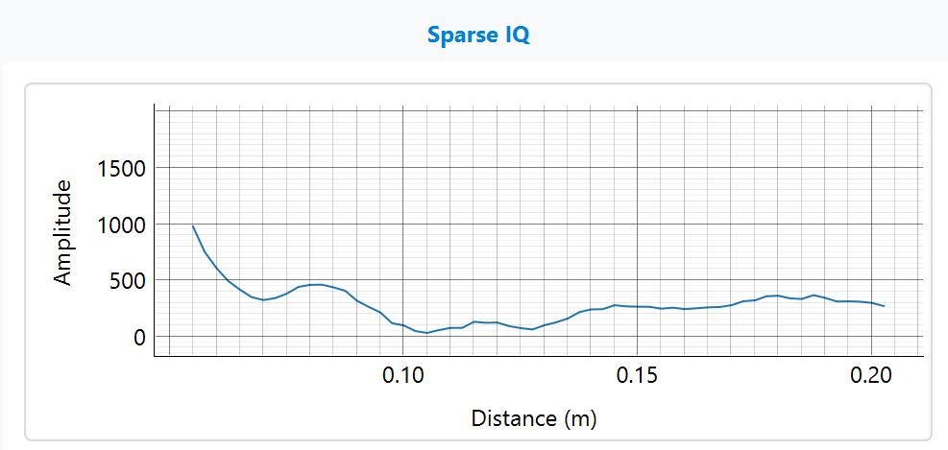

Sweet Maria’s - Flat layer of beans

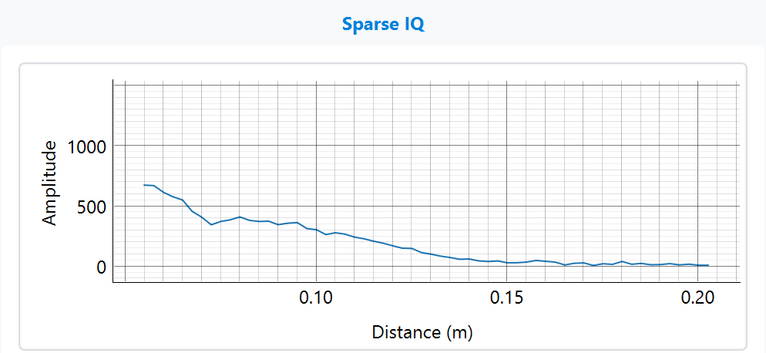

Tailored Pulped Natural Brazil - Flat layer of beans

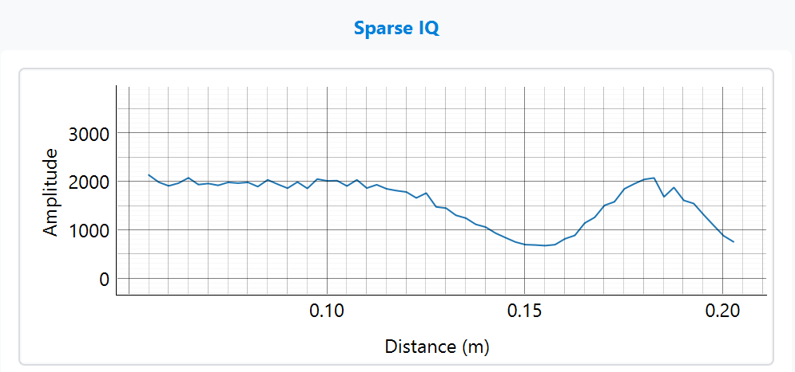

Comicovel - Flat layer of beans

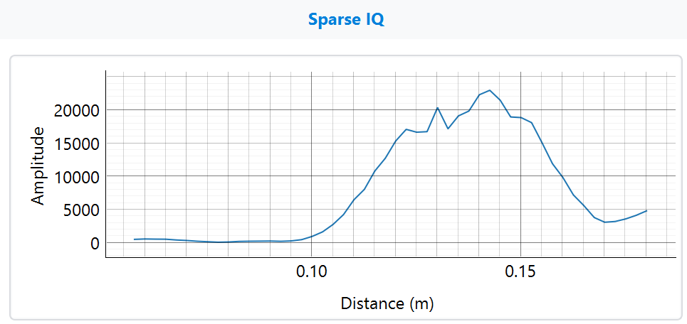

Beanis - No Beans

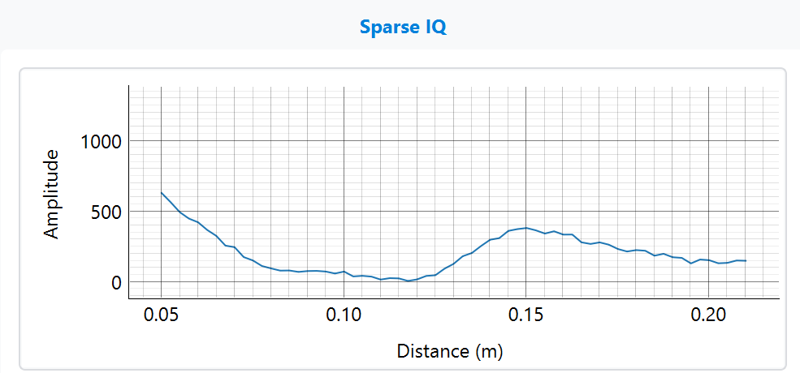

Beanis -